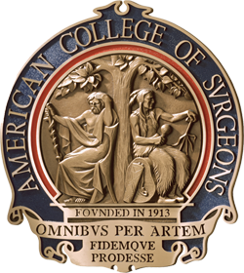
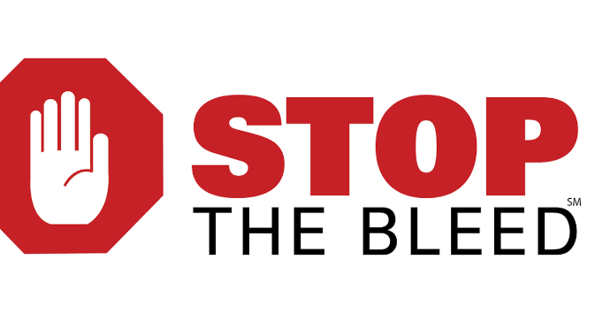

www.peacehealth.org/stopthebleed
www.bleedingcontrol.org
- Determine audience, location, time, and place
- Advertise the class(es)
- Gather teaching supplies
- Confirm adequate instructors with a 1:8 ratio
- Schedule 1 hour period per set of students
- 15-minute set-up and clean-up
- Have participants sign in
- Conduct lecture (20 minutes)
- Conduct two station (wound packing and use of tourniquets) each 20 minutes
- Distribute completion certificates as able
- Identify early, those who qualify as instructors
- Hold Trainer meeting for 15 minutes after the initial training
- Identify those on sign-in sheet who are now trainers
- Email, fax the sign in sheets regularly
- Conduct as many classes as possible
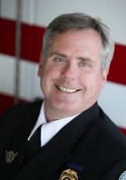
Jim Cole, LP, MAHE, NRP, FP-C, CEMSO, CMTE
EMS Coordinator | PeaceHealth Oregon Network
www.PeaceHealth.org/EMS | 3333 RiverBend Drive | Springfield, OR 97477
jcole3@peacehealth.org | office 541-222-1794 | mobile/txt 541-525-9115

