Test | Test Codes | Swab / Transport Device. Stability and Transport Conditions |  | Specimen Source
CT/NG, Trichomonas, Mycoplasma genitalium | LAB7062 | 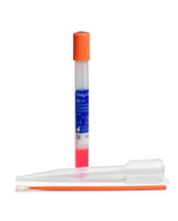  14 days at Room Temp (RT).  Abbott Alinity M multi-Collect reference number: 09N19-015  Order through Infor (each box contains 500 swabs) |  | Transport Device: Alinity M multi-Collect.  Source: vaginal, endocervical and male urine.  Female urine please order LAB6590.  Use orange handled swab or urine (FILL URINE TO MIDDLE OF WINDOW LINE).
CT/NG, Trichomonas | LAB6590 |  |  | Transport Device: Alinity M multi-Collect.  Source: vaginal, endocervical and male and female urine.  Use orange handled swab or urine (FILL URINE TO MIDDLE OF WINDOW LINE).
CT/NG | LAB8054 |  |  | Transport Device: Alinity M multi-Collect.  Source: Vaginal, endocervical and male and female urine.  Use orange handled swab or urine (FILL URINE TO MIDDLE OF WINDOW LINE).
CT/NG Throat | LAB8085 (throat) |  |  | Transport Device: Alinity M multi-Collect  Source: Throat  Use orange handled swab
CT/NG Rectal | LAB8079 (rectal) |  |  | Transport Device: Alinity M multi-Collect  Source: Rectal  Use orange handled swab
Xpert Swab, Vaginal Pathogen PCR. Bacterial vaginosis, Trichomonas and yeast. | LAB7724 | 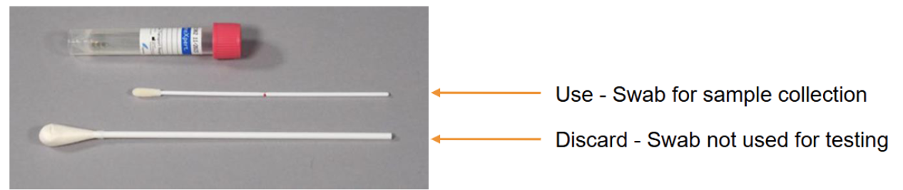  Transport Device: Xpert Swab Specimen Collection Kit.  Source: Vaginal. Stable 42 days at Room Temperature.
CT/NG, bacterial vaginosis, Trichomonas and Yeast | LAB8054  &  LAB7724 | Requires both Alinity (CT/NG) and Xpert swab (vaginosis / vaginitis). 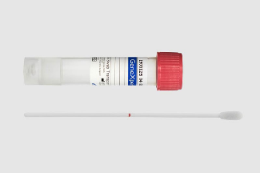
Group B Streptococcus detection (prenatal) | LAB8631  &  LAB6497 (PCN allergy) | 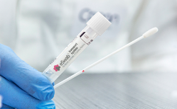 | 24 hrs. at RT. Swabs received 24 hours to 6 days after collection will be run with a disclaimer. | Transport Device: eSwab  Source: Vaginal/Rectal  Mfg. part number 480C  Order through Medline Punchout
Aerobic culture | LAB8059 |  | eSwab: Stable 48 hours at RT.  Aspirate abscess material and tissue may be placed in the transport medium. Do not overfill. | Transport Device: eSwab  Source: Various specimen sources.  Mfg. part number 480C  Order through Medline Punchout
aerobic and anaerobic culture. | LAB8058 |  | 24 hrs. at RT. Swabs received 24 hours to 6 days after collection will be run with a disclaimer. | Transport Device: eSwab  Source: Vaginal/Rectal  Mfg. part number 480C  Order through Medline Punchout
Staphylococcus aureus culture | LAB2882 |  | eSwab: Stable 48 hours at RT.  Aspirate abscess material and tissue may be placed in the transport medium. Do not overfill. | Transport Device: eSwab  Source: Various specimen sources.  Mfg. part number 480C  Order through Medline Punchout

