**Basic EKG Rhythm Interpretation**

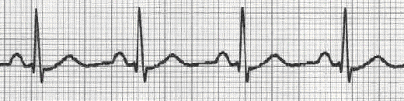

How to Analyze a Rhythm

**Lead Placement**

Each lead is made up of a negative (-) and a positive (+) electrode. The electrodes sense both the magnitude and direction of the electrical forces and record surface information from the heart.

Think of leads as simply providing different view or angles in which to view the heart’s electrical activity. A **12 lead EKG** system has five electrodes. One electrode is placed on each extremity while the 5th electrode is used as a floating electrode (used for recording from the chest wall).

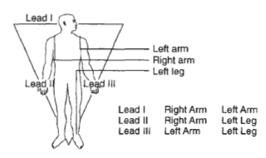

Ventricular depolarization is recorded on the EKG as a QRS complex. QRS complexes are either positive (upright) or negative (directed downward). When the major force or direction of depolarization spreads through the heart towards a positive electrode, the QRS deflection on the EKG will appear upright or positive. If the major force or direction of depolarization spread through the heart away form a positive electrode, or towards a negative electrode the QRS deflection will appear negative or directed downward.

Leads I, II, III are **standard limb leads** and the record for frontal plane activity. These are bipolar leads (each of the leads has two electrodes which record the electrical potential of the heart flowing toward two extremities). It is important to remember that the 12-lead ECG provides information about the heart's electrical activity in 3 approximately directions:

|  |  |  |
| --- | --- | --- |
| http://library.med.utah.edu/kw/ecg/pics/Bullet7.gif Right | http://library.med.utah.edu/kw/ecg/pics/Bi-arrow.gif | Left |
| http://library.med.utah.edu/kw/ecg/pics/Bullet7.gif Superior | http://library.med.utah.edu/kw/ecg/pics/Bi-arrow.gif | Inferior |
| http://library.med.utah.edu/kw/ecg/pics/Bullet7.gif Anterior | http://library.med.utah.edu/kw/ecg/pics/Bi-arrow.gif | Posterior |

Leads I, II, III are all electrically equidistant from the myocardial activity. The **right arm is always negative pole; the left leg is always positive pole**. The left arm electrode is positive in Lead I and negative in Lead III.

**Augmented Leads** are aVR, aVL, and a VF; these leads are unipolar. They increase the amplitude of the defections by 50% over standard limb leads.

aVR = augmented voltage right arm

aVL = augmented voltage left arm

aVF = augmented voltage foot

**Precordial Leads** are V1, V2, V3, V4, V5, and V6. The V leads record electrical potential in the horizontal plane and provides six views of the heart’s activity. There is a single positive electrode.

Leads I and aVL looks at the lateral surface of the left ventricle

Leads II, III, and aVF look at the inferior surface of the left ventricle

Leads V1, V2, V3, and V4 look at the anteroseptal surface of the left ventricle

Leads V5 and V6 looks at the apical surface of the left ventricle

There are no leads that view the posterior region of the left ventricle directly.

**Bedside Monitoring**

Most bedside monitoring utilizes a three lead system, a positive, a negative and a ground electrode.

**Conduction System**

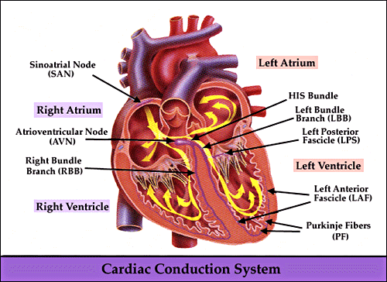

**Atrial Conduction**

**SA node** is the dominant pacemaker, is located in the right atrium at the opening of the superior vena cava. The SA node initiates an electrical impulse at a rate faster than other pacemaker sites. A cardiac rhythm that originates form the SA node is called sinus rhythm.

Other pacemaker sites include the AV node, bundle of His, bundle branches, and Purkinje network. The age of the person will reflect the normal SA node rate of electrical impulses per minute. This rate will increase with sympathetic stimulation (epinephrine) and slow with parasympathetic stimulation (Vagus nerve)

**AV node** has intrinsic automaticity with the ability to serve as a pacemaker in case of SA node failure. The AV node usually does not initiate impulses. The AV node and the bundle of His slow impulse conduction to allow the atria time to contract before ventricular contraction.

**Bundle of His** serves as an electrical connection between the atria and the ventricles.

**Ventricle Conduction**

**Bundle branches** and **Purkinje** fibers are specialized cardiac cells for fast conductivity. Bundle branches are encapsulated in connective tissue. The impulse must have traveled through the bundle of His to arrive at the bundle branches. If the impulse travels through the bundle of His, then it originated in either the bundle of His or above the bundle of His (i.e., the AV node, the atria or the SA node). **For a rapid wave of depolarization to envelop the ventricles, the impulse must originate above the ventricles.**

*A narrow QRS occurs when the impulse originates above the ventricles*.

A narrow QRS means a rapid ventricular depolarization, taking very little time.

An ectopic impulse originating in the right ventricle depolarizes the right and then the left ventricle. More distance is covered by the one wave, taking more time, with more time taken for ventricular depolarization, a widen QRS results.

*A wide QRS is commonly associated with ventricular rhythms*

Is the QRS wide or narrow? Now you can differentiate between supraventricular and ventricular rhythms

**EKG Wave Forms**



**P Wave** represents the depolarization of the right and left atria.

**PR segment** is the line between the end of the P wave and the beginning of the QRS complex. The PR segment signifies the time taken to conduct through the slow AV junction.

**PR interval** is measured from the start of the P wave to the beginning of the QRS complex. A Q wave is not always present on an EKG tracing.

The PR interval can provide clues to both the location or the originating impulse and the integrity of the conduction pathways of the heart. A PR interval longer than normal suggests that conduction is abnormally slow through the AV junction. This is called a first degree AV block. A PR interval shorter than normal occurs with a junctional rhythm.

**QRS complex** represents the depolarization of the ventricles. The repolarization of the atria is buried in the QRS complex.  **The width of the QRS complex often indicates the location of the originating electrical impulse.**

**Q** wave is the first negative deflection of the QRS complex. A normal Q is narrow and small in amplitude, no deeper than 2mm and less than one small square in width on EKG paper.

**QT interval** represents a complete ventricular cycle of depolarization and repolarization. The QT interval is measured from the beginning of the QRS complex to the end of the T wave. A prolonged QT is associated with a high incidence of sudden death.

**R** wave is the first positive deflection of the QRS complex.

**S** wave is the first wave of the R wave that dips below the baseline (isoelectric line).

**ST segment** is located between the QRS complex and the T wave. The ST segment shows early repolarization of the ventricles. The segment usually lies along the EKG baseline. The heart does not have any electrical activity during this time. The ST segment begins at the J point and stops at the beginning of the T wave. ST deviation is a sign of myocardial ischemia, myocardial infarction and cardiac disease. ST changes (elevations or depressions) are suggestive of current events as in now.

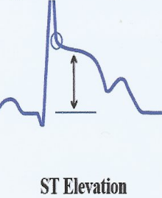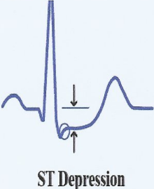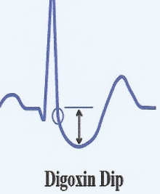

**J** point is the end of the S wave where the S wave begins to flatten out.

**T wave** represents the repolarization of the ventricle. The T wave is normally asymmetrical and is usually larger than the P wave. The T wave is upright in the lead II. As heart rates increase the P wave and the T wave can share the same space on an EKG. Abnormally shaped T waves can show acute episodes of cardiac ischemia, electrolyte imbalances, and the use of cardiac medications.

**U Wave** follows the T wave and before the P wave, is the final stage of repolarization. The U wave most often is in the same direction as the T wave with less amplitude. Abnormal U waves are associated with conditions such as hypokalemia, diabetes, ventricular hypertrophy, and cardiomyopathy.

**Heart Rate and Pulse Rate**

Heart rate is the number of QRS complexes present in a minute.

Pulse rate is the rate of perfusion of blood to the tissue

*Heart rate is not always the same as pulse rate*

**Calculating Heart Rate**

**Six Second Count**, multiplying the number of QRS complexes found over six seconds by a factor of 10 to get the QRS complexes found in a minute.

**|**  **3 sec | 3 sec |**

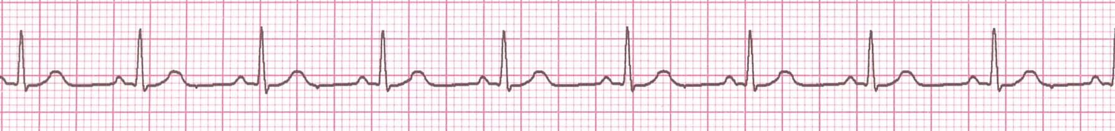

9x10=90

**Triplicate** the fastest method to figure a regular heart rate. Memorize the following numbers 300, 150, 100, 75, 60, 50

3 1 1

0 5 0 7 6 5 4 3 3 3 2

↓ 0 0 0 5 0 0 3 8 3 0 7



↑ ↑

Find an R wave that land on a bold line.

Count the # of large boxes to the next R wave. If the second R wave is one large box away, the rate is 300, two boxes - 150, three boxes - 100, four boxes - 75, etc. *Approx. 1 box less than 100 = 95 bpm*

**\*Normal Sinus Rhythm**

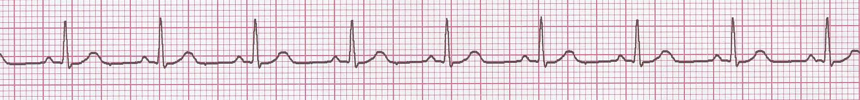

The electrical impulse is formed in the SA node and conducted normally.

This is the normal rhythm of the heart; other rhythms that do not conduct via the typical pathway are called arrhythmias.

Rate 60 - 100 bpm (adult) **age dependent in pediatrics**

Regularity regular

P waves normal

PR interval 0.12 - 0.20 s

QRS duration 0.04 - 0.12 s

Any deviation from above is sinus tachycardia, sinus bradycardia or an arrhythmia

**Arrhythmias**

Arrhythmias can arise from problems in the:

Sinus node

Firing to slow = Sinus bradycardia

Firing to fast = Sinus tachycardia

*Sinus tachycardia may be an appropriate response to stress*

Atrial cells

Fire occasionally from a focus = Premature Atrial Contraction (PAC’s)

Fire continuously due to a looping reentrant circuit = Atrial Flutter

Fire continuously from multiple foci or

fire continuously due to multiple micro re-entrants = Atrial Fibrillation

AV junction

Fire continuously due to a looping reentrant circuit = Supraventricular Tachycardia

Block impulses coming from the SA node = AV Junctional Block

Ventricular cells

Fire occasionally from 1 or more foci = Premature Ventricular Contractions (PVC’s)

Fire continuously from multiple foci = Ventricular Fibrillation

Fire continuously due to a looping reentrant circuit = Ventricular Tachycardia

**\*Sinus Bradycardia**

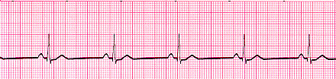

A heart rate less than 60 beats per minute (BPM).

Looking at the ECG you'll see that:

* Rhythm - Regular
* Rate - less than 60 beats per minute
* QRS Duration - Normal
* P Wave - Visible before each QRS complex
* P-R Interval - Normal
* Usually benign and often caused by patients on beta blockers

**\*Sinus Tachycardia**

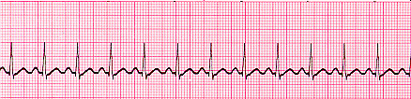

Looking at the ECG you'll see that:

* Rhythm - Regular
* Rate – Greater then norm for child’s age
* QRS Duration - Normal
* P Wave - Visible before each QRS complex
* P-R Interval - Normal
* The impulse generating the heart beats are normal, but they are occurring at a faster pace than normal.

**\*Supraventricular Tachycardia (SVT)**

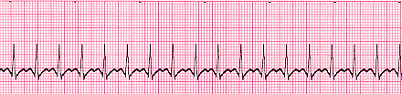

A narrow complex tachycardia or atrial tachycardia which originates in the 'atria' but is not under direct control from the SA node.

Looking at the ECG you'll see that:

* Rhythm - Regular
* Rate – Greater than 180
* QRS Duration - Usually normal
* P Wave - Often buried in preceding T wave
* P-R Interval - Depends on site of supraventricular pacemaker
* Impulses stimulating the heart are not being generated by the sinus node, but instead are coming from a collection of tissue around and involving the atrioventricular (AV) node

**Atrial Fibrillation**

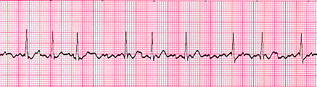

Many sites within the atria are generating their own electrical impulses, leading to irregular conduction of impulses to the ventricles that generate the heartbeat. This irregular rhythm can be felt when palpating a pulse.

Looking at the ECG you'll see that:

* Rhythm - Irregularly irregular
* Rate – Atrial rate ranges from 350-600 per min. The ventricular response is irregularly irregular and may be fast or slow.
* QRS Duration - Usually normal
* P Wave - Not distinguishable as the atria are firing off all over
* P-R Interval - Not measurable
* The atria fire electrical impulses in an irregular fashion causing irregular heart rhythm

**Atrial Flutter**

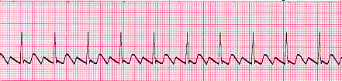

As with SVT the abnormal tissue generating the rapid heart rate is also in the atria, however, the atrioventricular node is not involved in this case.

Looking at the ECG you'll see that:

* Rhythm - Regular
* Rate – Atrial rate ranges 240 – 300 per min.
* QRS Duration - Usually normal
* P Wave - Replaced with multiple F (flutter) waves, usually at a ratio of 2:1 (2F - 1QRS) but sometimes 3:1
* P Wave rate - 300 beats per minute
* P-R Interval - Not measurable

**1st Degree AV Block**

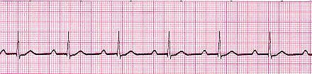

Looking at the ECG you'll see that:

* Rhythm - Regular
* Rate - Normal
* QRS Duration - Normal
* P Wave - Ratio 1:1
* P Wave rate - Normal
* P-R Interval - Prolonged (>5 small squares)

**2nd Degree Block Type 1 (Wenckebach)**

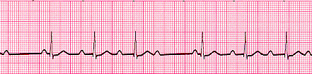

Looking at the ECG you'll see that:

* Rhythm - Regularly irregular
* Rate - Normal or Slow
* QRS Duration - Normal
* P Wave - Ratio 1:1 for 2, 3 or 4 cycles then 1:0.
* P Wave rate - Normal but faster than QRS rate
* P-R Interval - Progressive lengthening of P-R interval until a QRS complex is dropped

**2nd Degree Block Type 2**

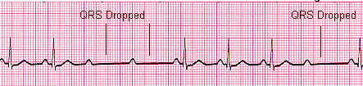

Looking at the ECG you'll see that:

* Rhythm - Regular
* Rate - Normal or Slow
* QRS Duration - Prolonged
* P Wave - Ratio 2:1, 3:1
* P Wave rate - Normal but faster than QRS rate
* P-R Interval - Normal or prolonged but constant

**3rd Degree Block**

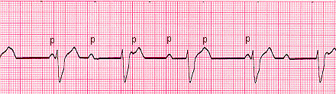

Looking at the ECG you'll see that:

* Rhythm - Regular
* Rate - Slow
* QRS Duration - Prolonged
* P Wave - Unrelated
* P Wave rate - Normal but faster than QRS rate
* P-R Interval - Variation
* Complete AV block. No atrial impulses pass through the atrioventricular node and the ventricles generate their own rhythm

**Bundle Branch Block**

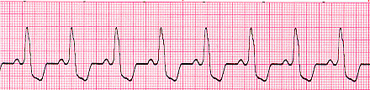

Looking at the ECG you'll see that:

* Rhythm - Regular
* Rate - Normal
* QRS Duration - Prolonged
* P Wave - Ratio 1:1
* P Wave rate - Normal and same as QRS rate
* P-R Interval - Normal

**Premature Ventricular Complexes**

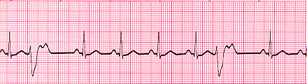

Looking at the ECG you'll see that:

* Rhythm - Regular
* Rate - Normal
* QRS Duration - Normal
* P Wave - Ratio 1:1
* P Wave rate - Normal and same as QRS rate
* P-R Interval - Normal
* Also you'll see 2 odd waveforms, these are the ventricles depolarizing prematurely in response to a signal within the ventricles.(Above - unifocal PVC's as they look alike if they differed in appearance they would be called multifocal PVC's, as below)

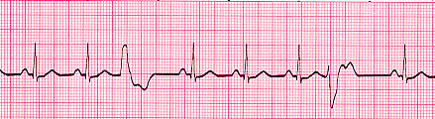

**Junctional Rhythms**

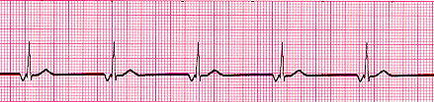

Looking at the ECG you'll see that:

* Rhythm - Regular
* Rate - 40-60 Beats per minute
* QRS Duration - Normal
* P Wave - Ratio 1:1 if visible. Inverted in lead II
* P Wave rate - Same as QRS rate
* P-R Interval - Variable
* Below - Accelerated Junctional Rhythm

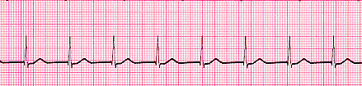

**\*Ventricular Tachycardia (VT)**

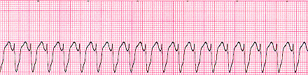

Looking at the ECG you'll see that:

* Rhythm - Regular
* Rate - 180-190 Beats per minute
* QRS Duration - Prolonged
* P Wave - Not seen
* Results from abnormal tissues in the ventricles generating a rapid and irregular heart rhythm. Poor cardiac output is usually associated with this rhythm thus causing the pt to go into cardiac arrest. Shock this rhythm if the patient is unconscious and without a pulse

**\*Ventricular Fibrillation (VF)**

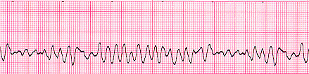

Looking at the ECG you'll see that:

* Rhythm - Irregular
* Rate - 300+, disorganized
* QRS Duration - Not recognizable
* P Wave - Not seen
* This patient needs to be defibrillated!! QUICKLY

**\*Asystole**

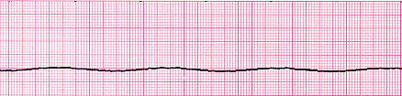

Looking at the ECG you'll see that:

* Rhythm - Flat
* Rate - 0 Beats per minute
* QRS Duration - None
* P Wave - None
* Carry out CPR!!!

NOTES: