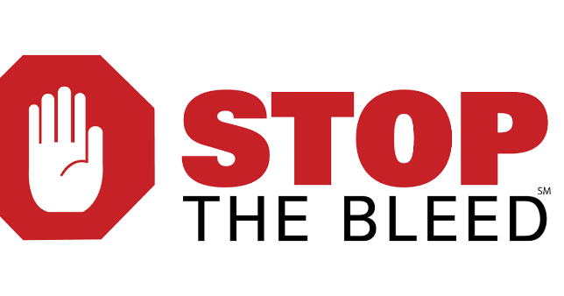

How to Create a Cheap Training Kit
- Each kit trains 8 people
- Buy 36” hard foam roller/pool noodles and cut into 3rds
- Use 2 rolls of 4” Coban material to wrap each section
- Create wounds using permanent red magic marker
  - One deep enough to wound pack near bottom
  - Several “small bullet holes” near top
  - One 1” wide near middle and opposite the bullet holes
  - One superficial wound
- 2 clean towels
- 4 rolls of roller gauze
- 2 tourniquets
- Gloves or zip lock bags
- 1 pair of scissors
- Medium point Sharpie
- Handouts and other materials for participants
- Tote with supplies and checklist

www.peacehealth.org/stopthebleed
Jim Cole, LP, MAHE, NRP, FP-C, CEMSO, CMTE
EMS Coordinator | PeaceHealth Oregon Network
www.PeaceHealth.org/EMS | 3333 RiverBend Drive | Springfield, OR 97477
jcole3@peacehealth.org | office 541-222-1794 | mobile/txt 541-525-9115

